

Database Management System
Teacher Name: Dr Sarmad Shaik
Assignment: 01

Name: Bushra Jan
Student ID: CSC-25F-603
Section: 2C
Department: BS CS (Evening)

a
VertixCompany Database
Database (VertixCompany)

1. Database Creation
- First, a database named VertixCompany was created. | 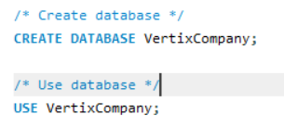

2. Tables Creation
Departments Table  - This table is used to store department information.  - It has two columns:  - Dept_Id (Primary Key, Auto Increment)  - Dept_Name (Name of department)  MySQL Code:  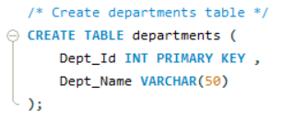 | 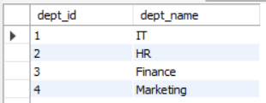

Employees Table  - This table stores employee information.  - It contains the following columns:  - Emp_Id (Primary Key, Auto Increment)  - Emp_Name (Employee name)  - Email (Employee email address)  - Salary (Employee salary)  - Join_Date (Date of joining)  - Dept_Id (Foreign key linked with Departments table) | MySQL Code:  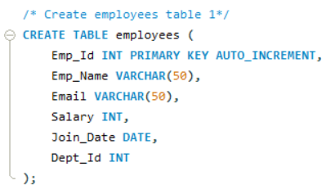
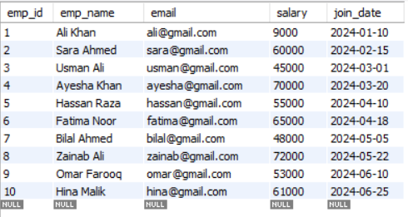

Attendance Table  - This table stores attendance records of employees.  - It contains:  - Att_Id (Primary Key, Auto Increment)  - Emp_Id (Foreign key linked with Employees table)  - Att_Date (Date of attendance)  - Status (Present or Absent) | 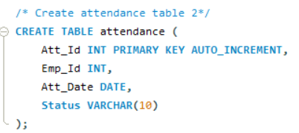

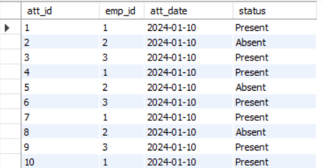

3. Relationships (Foreign Keys)  - Employees table is connected with Departments table using Dept_Id.  - Attendance table is connected with Employees table using Emp_Id.  These relationships help to connect all tables properly. | 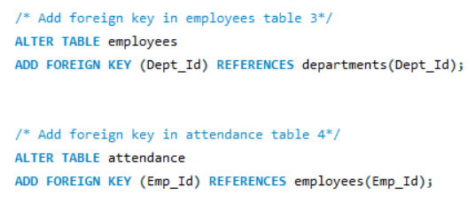

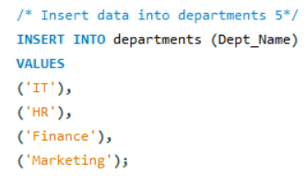
4. Data Insertion
- Data was added into all tables.

Departments Data:
- IT
- HR
- Finance
- Marketing
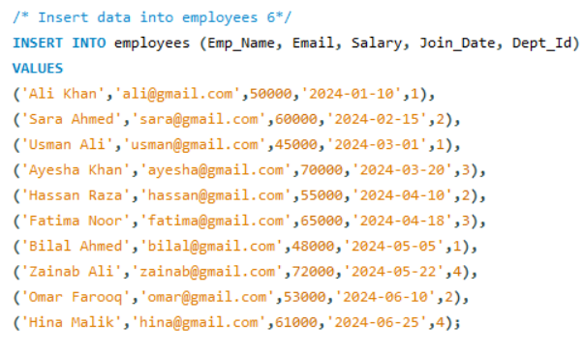
Employees Data:
- 10 employees were added with their details like name, email, salary, joining date and department.

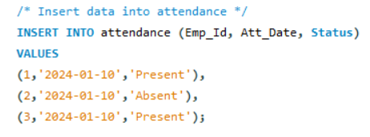
Attendance Data:
- Attendance records were added for some employees.
- Status was marked as Present or Absent.

5. Data Display
- SELECT queries were used to view all data from:
  - Employees table
  - Departments table
  - Attendance table
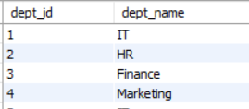
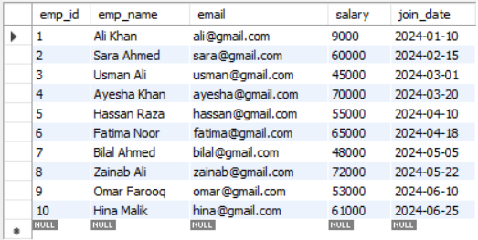

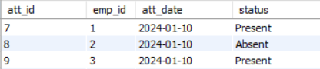

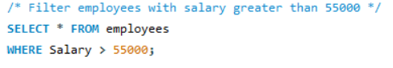
6. Data Filtering
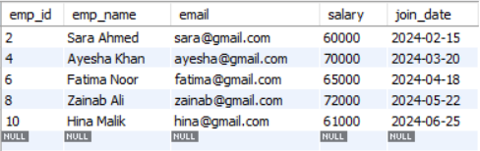
- Employees were filtered whose salary is greater than 55000.

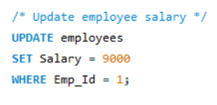
7. Data Update
- One employee’s salary was updated using UPDATE query.

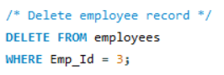
8. Data Deletion
- One employee record was deleted using DELETE query.

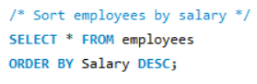
9. Sorting Data
- Employees were sorted in descending order based on salary.

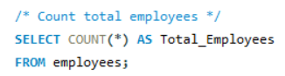
10. Counting Data
- Total number of employees was calculated using COUNT function.

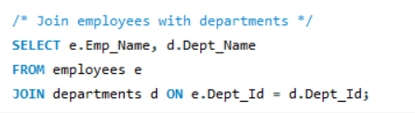
11. Joining Tables
- Employees table was joined with Departments table.
- This shows each employee with his or her department name.

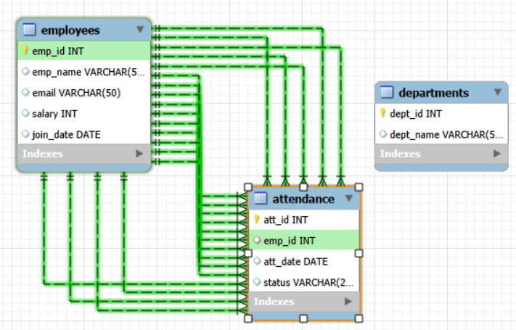

Conclusion
- This project shows how a database is created and managed.
- It includes tables, relationships, and different SQL operations.
- It helps to understand basic database concepts like insert, update, delete, select, and join.

